Fairy
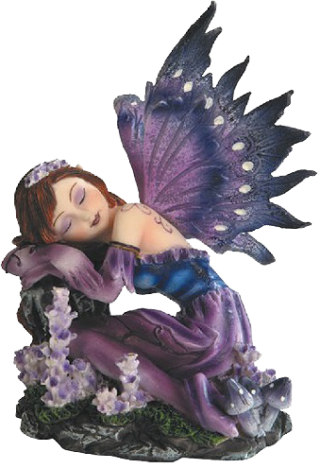
Alternate titles: faerie, faery
Fairy, also spelled faerie or faery, a mythical being of folklore and romance usually having magic powers and dwelling on earth in close relationship with humans. It can appear as a dwarf creature typically having green clothes and hair, living underground or in stone heaps, and characteristically exercising magic powers to benevolent ends; as a diminutive sprite commonly in the shape of a delicate, beautiful, ageless winged woman dressed in diaphanous white clothing, inhabiting fairyland, but making usually well-intentioned intervention in personal human affairs; or as a tiny, mischievous, and protective creature generally associated with a household hearth.
While the term fairy goes back only to the Middle Ages in Europe, analogues to these beings in varying forms appear in both written and oral literature, from the Sanskrit gandharva (semidivine celestial musicians) to the nymphs of Greek mythology and Homer, the jinni of Arabic mythology, and similar folk characters of the Samoans, of the Arctic peoples, and of other indigenous Americans. The common modern depiction of fairies in children’s stories represents a bowdlerization of what was once a serious and even sinister folkloric tradition. The fairies of the past were feared as dangerous and powerful beings who were sometimes friendly to humans but could also be cruel or mischievous.
Fairies are usually conceived as being characteristically beautiful or handsome and as having lives corresponding to those of human beings, though longer. They have no souls and at death simply perish. They often carry off children, leaving changeling substitutes, and they also carry off adults to fairyland, which resembles pre-Christian abodes of the dead. People transported to fairyland cannot return if they eat or drink there. Fairy and human lovers may marry, though only with restrictions whose violation ends the marriage and, often, the life of the human. Some female fairies are deadly to human lovers. Fairies are said to be of human size or smaller, down to a height of 3 inches (7.5 cm) or less. Female fairies may tell fortunes, particularly prophesying at births and foretelling deaths. Several herbs, especially St.-John’s-wort and yarrow, are potent against fairies, and hawthorn trees, foxglove, and groundsel are so dear to them that abuse of these plants may bring retribution.
Fairy lore is particularly prevalent in Ireland, Cornwall, Wales, and Scotland. Fairies are common in literature from the Middle Ages on and appear in the writings of the Italians Matteo Boiardo and Ludovico Ariosto, the English poet Edmund Spenser, the Frenchman Charles Perrault, and the Dane Hans Christian Andersen, among others.

